SSL Connection between Datastage and DB2
Prerequisite
    - Log in as db2 user a1insiwp
    - Run below command to see if gskit7 or gskit8 is installed in the server. If not, follow below instruction to download and install.
# /home/a1insiwp> which gsk7capicmd

# /home/a1insiwp> which gsk8capicmd

Download package sds631_aix_ppc64_gskit.tar from below link of this RTC task 123795 and put into the a certain directory of datastage server
http://bejgsa.ibm.com/gsa/bejgsa/home/d/l/dlyt/web/public/gskit/sds631_aix_ppc64_gskit.tar
    - CA Certificate

GSKit Installation
    - Extract the tar package of the GSKit file

# /home/a1insiwp> tar -xvf <package_extracted_directory>/sds631_aix_ppc64_gskit.tar

    - Go to the directory where the gskit tar was extracted and go directly down to the directory where all the .rte files are.
    - Type following command to lauch the installation system, as below snapshot.

# /home/a1insiwp> smitty

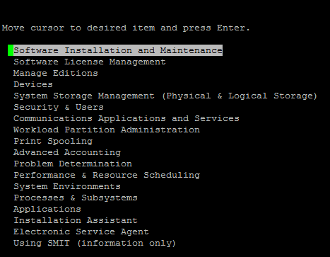

    - Choose "Software Installation and Maintenance" and type "Enter" and go on as below.

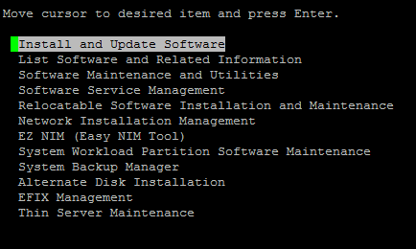

    - Choose "Install and Update Software" and type "Enter" and go on as below.

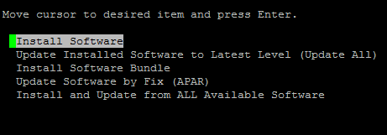

    - Choose "Install Software" and type "Enter" and type in the directory where you want to install it and change " ACCEPT new license agreements?" from "no" to "yes" by typing "Tab" button.

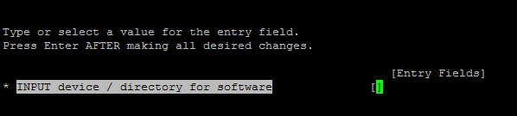

    - Type "Enter" until it starts to install.

    - Add system environmental variables so that we can directly use the command gsk% later.

# /home/a1insiwp> export LIBPATH = <existing value.>:<Installed Directory>/gsk%/lib

Configuration on Datastage server
    - Open a command line or terminal and make a new directory in the DataStage system to store the SSL certificate and key files.

# /home/a1insiwp> mkdir SSL
# /home/a1insiwp> cd SSL

    - Save the certificates into the SSL directory you made in step 1.
    - Create a client keystore database in the DataStage system by using the gsk8capicmd utility. This utility is included in the DB2® server installation.

# /home/a1insiwp/SSL> gsk8capicmd -keydb -create -db <keystore_db.kdb> -pw <ks_db_password> -stash

where <keystore_db.kdb> represents the client keystore database and <ks_db_password> represents the password for the client keystore database.
    - Add the certificate to the client keystore database.

# /home/a1insiwp/SSL> gsk8capicmd -cert -add -db "db2_ssl_keydb.kdb" -stashed -label "IBMCA_Root" -file RDC_IBMCA_Root_Cert.der -format binary -fips -trust enable

# /home/a1insiwp/SSL> gsk8capicmd -cert -add -db "db2_ssl_keydb.kdb" -stashed -label "IBMCA_Intermediate" -file RDC_IBMCA_Intermediate_Cert.der -format binary -fips -trust enable

    - List the keystore databases that we just created and verify if they are existed.

# /home/a1insiwp/SSL> gsk8capicmd -cert -list -db db2_ssl_keydb.kdb -stashed

    - Update the SSL configuration parameters in the database manager.

# /home/a1insiwp/SSL> db2 update dbm cfg using SSL_CLNT_KEYDB /home/a1insiwp/SSL/db2_ssl_keydb.kdb

# /home/a1insiwp/SSL> db2 update dbm cfg using SSL_CLNT_STASH /home/a1insiwp/SSL/db2_ssl_keydb.sth

    - Catalog the target node with the SSL security option and then the target database at that target node.

# /home/a1insiwp/SSL> db2 catalog tcpip node <node_name> remote <target_database_ip> server <port_number> security SSL

# /home/a1insiwp/SSL> db2 catalog db MAINSHAD as MAIN_S at node <node_name>

    - Terminate the db2 command.

# /home/a1insiwp/SSL> db2 terminate

    - Add read and execute permissions on the files in the SSL directory for everyone. The DataStage user who runs the jobs needs to access these files to make SSL connections to the Db2 database.

# /home/a1insiwp/SSL> chmod 655 /home/a1insiwp/SSL/*

    - Test if you can connect to the database from Datastage server.

# /home/a1insiwp/SSL> db2 connect to MAIN_S user <user_name> using <password>

Datastage Server Parameter File Settings
    - Update file varcreds.config from directory /var/datastage/scripts

$ cd /var/datastage/scripts
$ vi varcreds.config
change the value of CISF_DBConn to MAINSHAD
change the value of CISF_User to rdct1
change the value of CISF_Password to EsSISQQ5

    - Update file RTC_70942_ParamsUpd.txt from directory /var/datastage/scripts/parmfiles

$ cd /var/datastage/scripts/parmfiles
$ vi RTC_70942_ParamsUpd.txt
change the value of CISF_DB_ParamSet.ConnectionString to MAINSHAD
change the value of CISF_DB_ParamSet.Username to rdct1
change the value of CISF_DB_ParamSet.Password to EsSISQQ5

Save the file and quit.

    - Update file RTC_94724_ParamsUpd.txt from directory /var/datastage/scripts/parmfiles

$ cd /var/datastage/scripts/parmfiles
$ vi RTC_70942_ParamsUpd.txt
change the value of CISF_DB_ParamSet.ConnectionString to MAINSHAD
change the value of CISF_DB_ParamSet.Username to rdct1
change the value of CISF_DB_ParamSet.Password to EsSISQQ5

Save the file and quit.

    - Go to directory /var/datastage/scripts to run the shell script GenerateParamFiles.sh to refresh the values we just changed to make them effective.

$ cd /var/datastage/scripts
$ ./GenerateParamFiles.sh

